**Registration**:

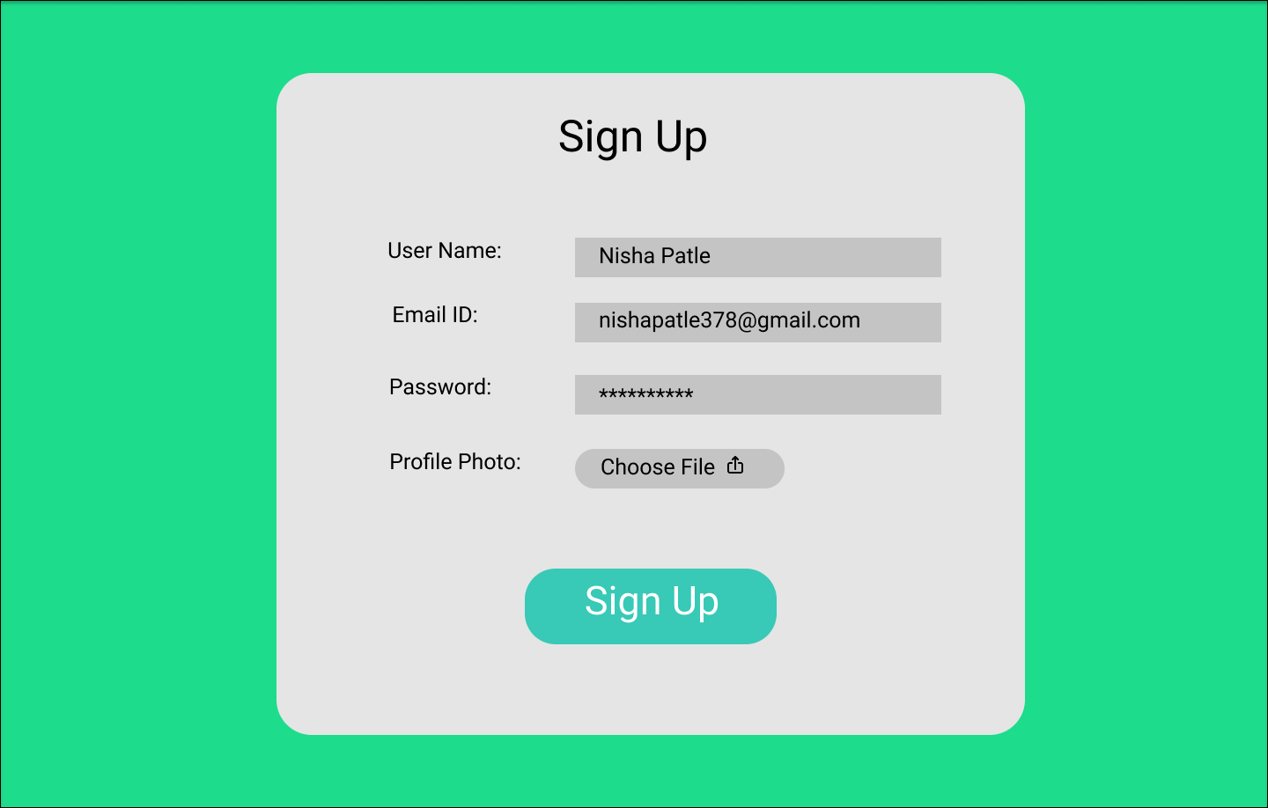

This is the first page. You need to apply validation and after Sign Up, there is auto-generated token with Sign Up API. For this table need to create CRUD API’s including get all users API.

For angular, you have to use angular material and for backend Node js and database should be Mongo DB Cloud.

**Login**

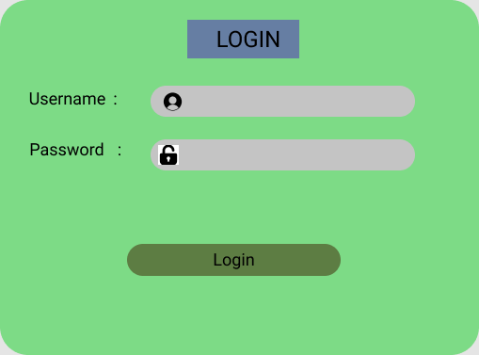

While Login, check authentication token, then navigate to Admin Page.

**Get all user**

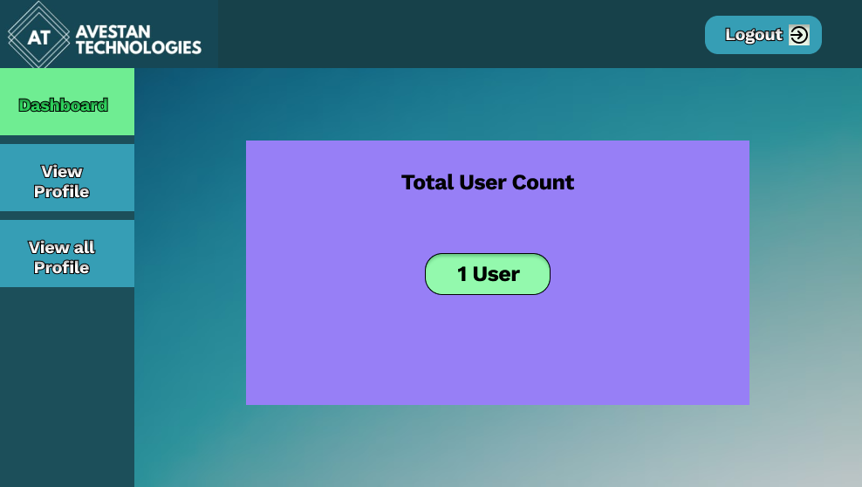

Total user count should display here on dashboard tab.

**User view**

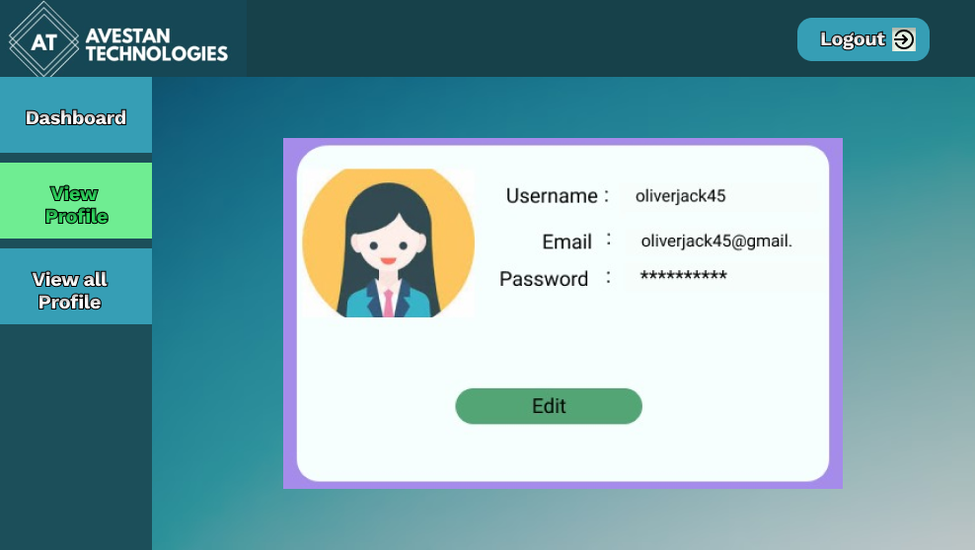

Here, you want to get user profile detail.

**Update**

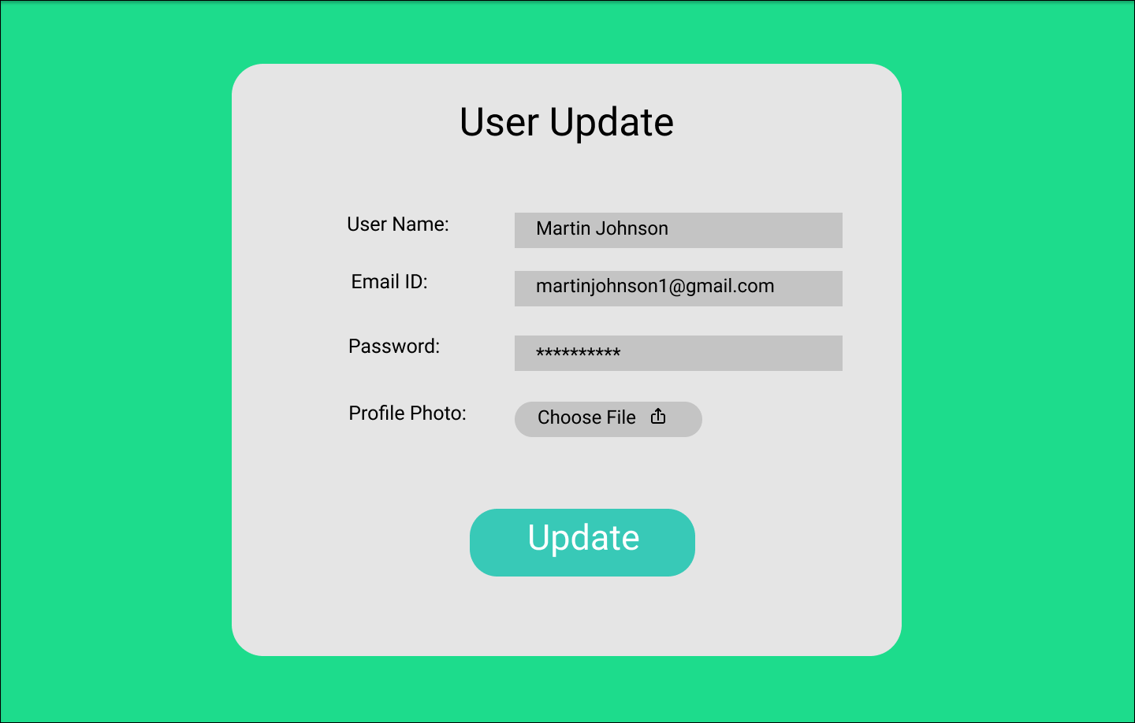

This is the user update page when clicked on Edit.

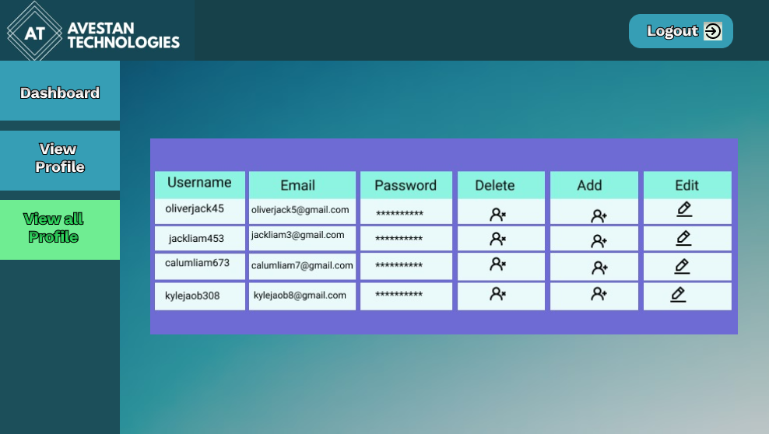

Here you have to show all user in Table. Skip add column, you have to do edit and delete operation. Create API for all this things and front end in angular material.